**Note on indicative business requirements for development of a Proposal Management System for RPL PMKVY 2016-20**

1. **About RPL**

RPL under PMKVY aims to align the competencies of the un-regulated workforce to the standardized National Skill Qualification Framework (NSQF) and enhance the employability opportunities of an individual as well as provide alternate route to higher education. It is implemented through five distinct project types.

Operationally, a project based approach is followed for allocation of targets to Project Implementing Agencies (PIAs) under RPL in PMKVY 16-20. This approach allows for inclusion of diverse entities and enables participation of a wider range of beneficiaries. PIA can be any legal entity such as Sector Skill Council (SSC), Industry Association, Training Provider, Government Body, NGO and Corporate, except Assessment Agency. A PIA can propose to conduct RPL at various locations and in different job roles across a particular sector. Job roles of NSQF level 2 and above are preferably eligible. Individual RPL projects for different sectors are approved by respective approval Committees constituted under PMKVY.

1. **Overall process of RPL delivery chain under PMKVY 2016-20**

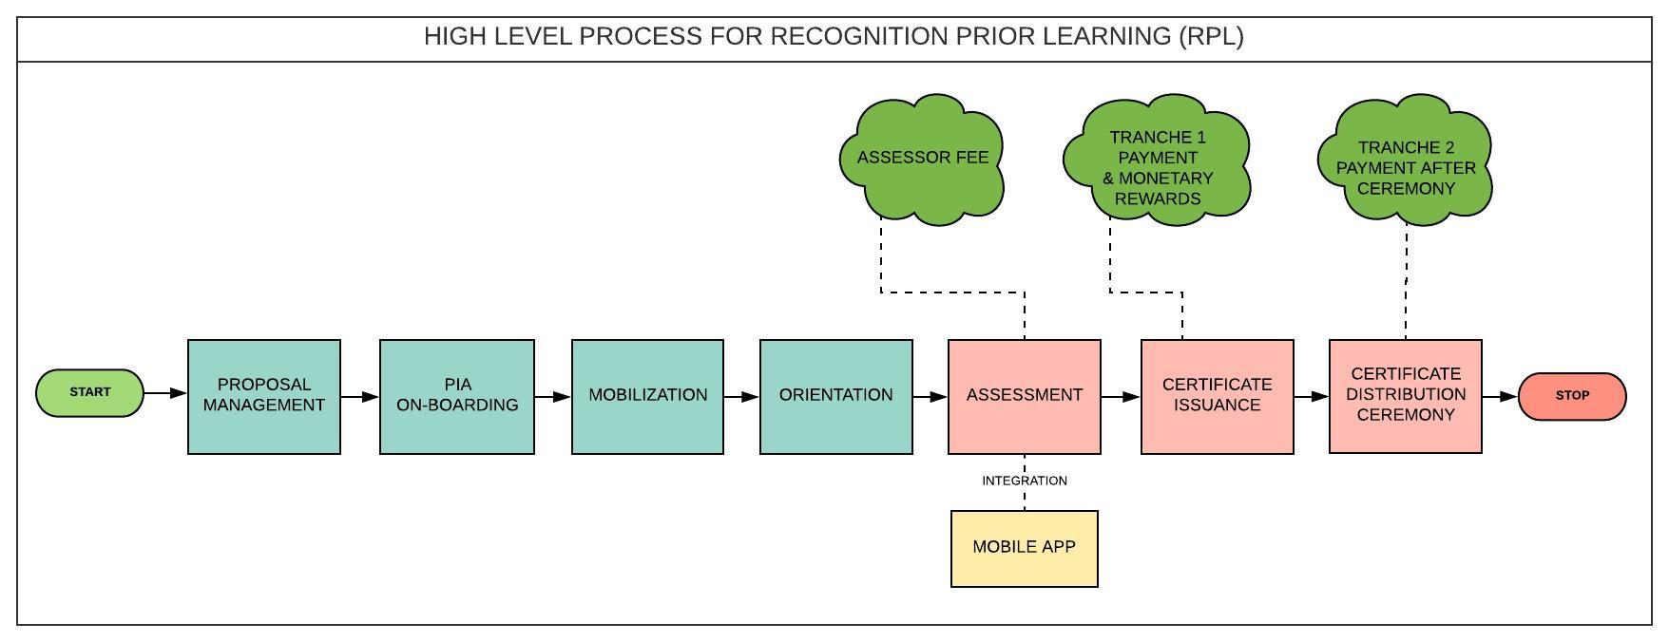

1. **Brief description of Proposal Management Process**

| **Process** | **Brief of Process Description** |
| --- | --- |
| Proposal Management | * Proposal along with annexure in NSDC approved format is submitted by PIA to SSC. * SSC conducts a preliminary evaluation of the proposal in line with the Scheme guidelines. In case the proposing entity is SSC, the proposal is submitted directly to NSDC and NSDC conducts the preliminary evaluation of the proposal document and related annexures. Upon preliminary evaluation, if a proposal is found to be compliant with the Scheme guidelines and is complete in line with the specified documentation, it is accepted and the PIA is acknowledged for the same. * In case the proposal is non-compliant with the Scheme guidelines, it is rejected and PIA is informed of the same. Also, if a proposal is found to be incomplete, it is returned to the PIA (with an acknowledgment to the SSC) for necessary action. RPL Team evaluates the complete and compliant proposals in line with pre-defined parameters and provides a score to the proposal. * The evaluated proposal is further presented to the PMKVY Screening Committee. The PMKVY Screening Committee (SC) provides its recommendation on the project proposal wherein eligible proposals are forwarded to the PMKVY Executive Committee (EC) Project proposals deemed suitable by the PMKVY Executive Committee are allocated targets. Project proposals that require further revision, as directed by the PMKVY Executive Committee are notified to the concerned PIA for re-submission. * PIAs and SSCs are informed for approval, rejection and re-submission accordingly. Further, for approved projects, a term sheet capturing recommendations of PMKVY SC and EC is prepared and project details are entered for confirmation of PIA on the same. * Term Sheet and Agreement is signed for PIA on-boarding. * Changes in implementation of project post approval can be initiated either by the PIA or by the NSDC team. This may involve change in state/sector/job role/other parameter and shall lead to changes in the Term sheet and Agreement for the project. * The change request, once initiated, is first presented to PMKVY SC and is followed through a similar process as mentioned above for approval. |

1. **Details of Proposal Management System**

This section covers the submission, evaluation, and screening and approval part of the proposal approval process. Below is a process map which indicates the process and actions taken by relevant stakeholders?

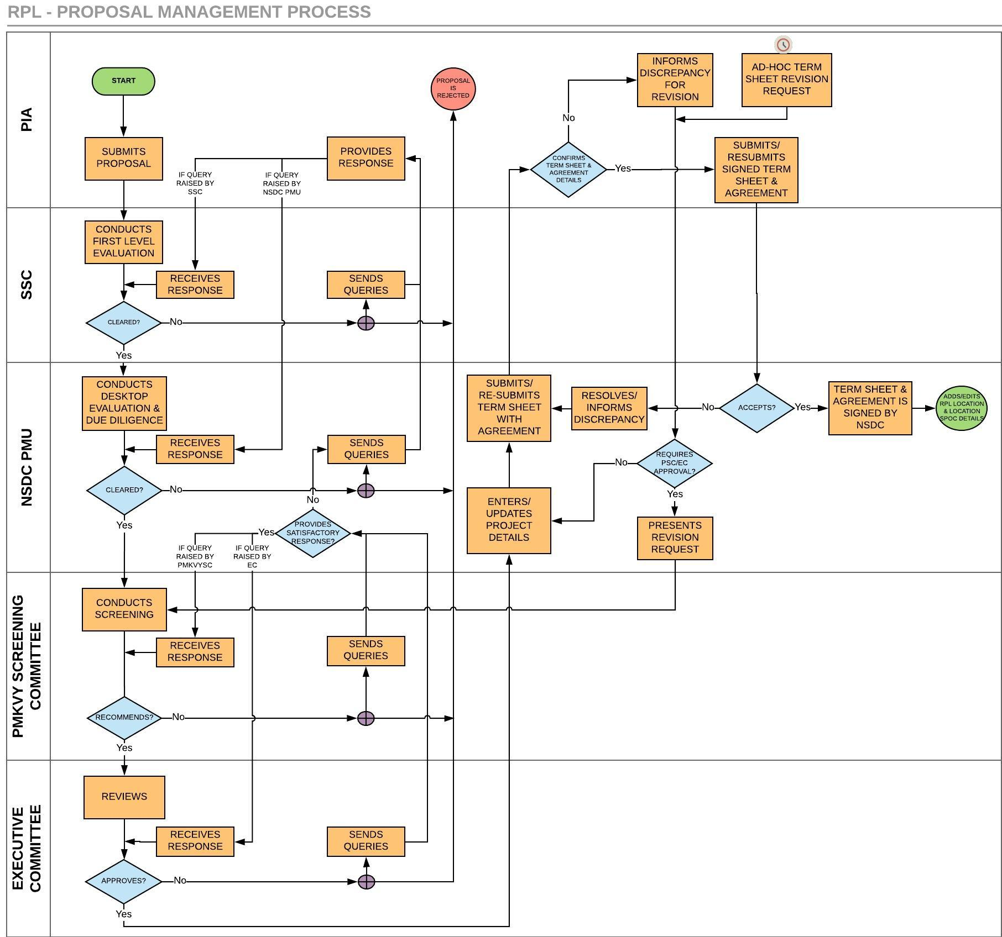

* 1. **Process steps**

| **Step#** | **Action** | **Description** | **Actor** | **Rule#** |
| --- | --- | --- | --- | --- |
| 1 | Submits the proposal | RPL Project Proposal are filled and relevant documents are uploaded online by PIA in NSDC approved format. Further, it is to be submitted to SSC in case of Non-SSC PIA or NSDC in case of SSC PIA. ***Mandatory fields like SSC or Non-SSC PIA, Government or Non-Government should be captured. | PIA | 1 |
| 2 | Conducts first level of Evaluation | First level of compliance based on scheme guidelines is checked.  Once the proposal is deemed to be compliant with the scheme guidelines, the SSC shall provide a recommendation on the proposal which is to be forwarded to NSDC along with proposal and related documents (recommendation specifically on the overall targets, job role and state coverage; format of recommendation letter to be given by NSDC)  SSC can send queries or can reject the proposal. *** In case of SSC PIA, each page of Proposal is filled & documents are signed by the competent authority of SSC and submitted to NSDC. NSDC PMU conducts the preliminary evaluation and fills the document checklist online.  In case of any non-compliance observed, sends the queries to PIA or rejects the proposal. | SSC | 1 |
| 3 | Conducts Desktop Evaluation & Due Diligence | Desktop evaluation and Due Diligence on the proposal is conducted and each proposal is scored in line with RPL Evaluation Scoring Matrix. Only complete and Scheme compliant proposals are marked as cleared by NSDSC for forwarding it to the PMKVY Screening Committee (PSC).  In case of queries, it is sent to SSC and/or PIA and response can be received.  The proposal can be rejected with remarks in case of any non-compliance observed. Based on inputs of PSC/EC while screening/reviewing the proposal, NSDC PMU can send queries/ request for upload of additional/ revised documents/annexures from PIA/ SSC and can receive a response. Also, the eligible Term Sheet revision request received from PIA/NSDC PMU can be presented before the respective committees. | NSDC PMU | 1 |
| 4 | Conducts Screening | NSDC PMU presents the evaluated proposal to PSC. Proposals deemed as eligible are further sent to EC.  PSC can send queries/ request for upload of additional/ revised documents/annexures from PIA/ SSC and can receive a response for the same. The proposal or Term Sheet revision request can also be rejected with remarks in case of any non-compliance observed. | SC | 1 |
| 5 | Reviews | EC reviews the proposal/request and approves with allocation of the targets. NSDC PMU can send queries/ request upload of additional/ revised documents/annexures from the PIA and/or SSC and can receive a response for the same.  The proposal can also be rejected in case of any non-compliance observed. | EC | 1 |
| 6 | Enters /Updates Project Details and prepares Term Sheet | Once approved, NSDC PMU fetches/enters/updates the Project Details and target allocation as per the approval.  (Details for Term sheet to be auto-populated from the proposal filled by the PIA. NSDC to have editable rights on the same.) NSDC PMU can also provide validation on assignment of trainer in the Project details. In case term sheet revision request, post approval of respective Committee the Project details are updated by NSDC PMU and intimated to PIA. | NSDC PMU | 2, 3, 4, 6, 7 |
| 7 | Submits Term Sheet & Agreement | Further, Term sheet along with Agreement is submitted for acceptance of PIA along with the Agreement for signing. | NSDC PMU |  |
| 8 | Confirms the Term Sheet & Agreement | PIA confirms the details mentioned in the Term Sheet and Agreement. | PIA |  |
| 9 | Submits/Re-submits signed Term Sheet & Agreement | Agreement & Term Sheet accepted by PIA is signed for submission to NSDC PMU. Approved Term sheet to have a printable option. | PIA |  |
| 10 | Term Sheet & Agreement is signed by NSDC | Post the Term Sheet & Agreement is checked and accepted by NSDC PMU, it is submitted to NSDC authority for signing it. | NSDC PMU | 2,3 |
| 11 | Resolves/Informs Discrepancy | In case of any discrepancy observed by NSDC PMU, it is either resolved or informed to PIA by re-submitting the Term Sheet & Agreement as per **Step#7**. | NSDC PMU |  |
| 12 | Informs Discrepancy for Revision | If the details of Term Sheet are not confirmed, PIA informs the discrepancy for revision in the Term Sheet.  This request could be raised by PIA on ad-hoc basis too.  Request for alteration in the Term sheet (along with justification for each change) can be submitted to NSDC for seeking approval. NSDC can reject or accept the change request (with an option o remarks to be added during acceptance/ rejection). Once NSDC presents the change request to SC, revision in Term sheet may be conducted online accordingly. | PIA |  |
| 13 | Presents Revision Request | Term Sheet revision request is checked and presented for Committee approval as per **Step# 5**. | NSDC PMU |  |

* 1. **Business rules**

| **Rule #** | **Description** |
| --- | --- |
| 1 | An action should be taken by NSDC on the proposal within XX days of submission and intimation should be sent to PIA. |
| 2 | Term sheet deemed as final only upon approval by NSDC PMU, post which specific details are updated either through Term sheet revision request on based on the desired inputs of NSDC. |
| 3 | Project to be marked as ‘Closed’ after Project End Date + 30 days (configurable) elapses. |
| 4 | After Project End Date + 30 days (configurable) elapses, targets remaining to be certified as against allocated should be marked as ‘Unachieved Targets’ for the project. |
| 5 | States approved in the Term sheet should be only populated in the drop down menu for providing the RPL District name, Constituency name, Location Address and Pin code. |
| 6 | NSDC PMU to have access to ‘edit’ i.e. extend Project End Date. Project End date to be editable until T+90 (configurable) days, T being Project End Date. |
| 7 | NSDC PMU can assign the validation on assignment of trainer in the Project details till the Project End date in format as below:   |  |  |  | | --- | --- | --- | | ***Trainer is required for a Batch*** | ***Effective From Date*** | ***Effective Till Date*** | | Yes | 01-Feb-2018 | 12-Feb-2018 | | No | 13-Feb-2018 | 15-Feb-2018 | | Yes | 16-Feb-2018 |  | |

* 1. **Functional requirements**

| **SN** | **Description** | **Process Step #** |
| --- | --- | --- |
| 1 | The System should allow PIA to fill and submit RPL proposal with mandatory/non-mandatory supporting documents. | 1 |
| 2 | The System should provide a feasibility with the Administrator in the System in case the proposal format is altered as per decision of MSDE. | 1 |
| 3 | The System should allow SSC to conduct first level of evaluation (i.e. check the document checklist of the proposal) after logging in using the login credentials in case of Non-SSC PIA. | 2 |
| 4 | The System should allow SSC to upload the documents like SSC Recommendation Letter (on Targets, States, Sector and Job role proposed for the project), Pre-screening sheet, Information of Assessment Agencies & other documents signed by competent authority of SSC in case of Non-SSC PIA. | 2 |
| 5 | The System should allow NSDC to login using the login credentials for conducting first level of evaluation (i.e. check the document checklist of the proposal) in case of SSC-PIA. | 3 |
| 6 | The System should allow SSC/NSDC PMU to provide cleared status to the first level evaluation or send queries/inputs or reject the proposal based on whether it’s a SSC or Non-SSC PIA proposal. | 2,3 |
| 7 | The System should allow NSDC PMU to verify/submit the scoring and conduct due diligence on the proposal received with the supporting documents from SSC. | 3 |
| 8 | The System should allow NSDC PMU to send queries/inputs to SSC and/ or PIA against the proposal submitted. | 3 |
| 9 | The System should allow SSC/PIA to provide response to the queries/inputs of NSDC PMU. | 1 |
| 10 | The System should allow NSDC PMU to present the proposal to PSC post clearing desktop evaluation and due diligence or allow NSDC PMU to reject the proposal in case of any non-compliance observed. | 3 |
| 11 | The System should will allow NSDC PMU to upload the additional document like presentation or supporting documents for presenting the proposal to PSC. | 3 |
| 12 | The System should allow entering the status as approved/rejected or send queries/inputs on behalf of PSC with an option to upload the documents like MoM etc. | 4 |
| 13 | The System should allow NSDC PMU to capture the response for queries/inputs raised by PSC. | 4 |
| 14 | The System should allow entering the status as approved/rejected or send queries on behalf of EC with an option to upload the documents such as MoM etc | 5 |
| 15 | The System should allow NSDC PMU to capture the response for queries/inputs raised by EC. | 5 |
| 16 | The System should allow fetch/enter Project details with target allocation based on the approval of EC. | 5, 6 |
| 17 | The System should allow NSDC PMU to create the term sheet based on the Project details for submission to PIA. | 6 |
| 18 | The System should have an option of downloading/printing the term sheet at each stage post it is created by NSDC PMU. | 6 |
| 19 | The System should allow NSDC PMU to submit the prepared Term sheet along with Agreement for confirmation of the Term Sheet details by PIA for signing it between PIA and NSDC. | 7 |
| 20 | The System should allow PIA to confirm the Term Sheet. | 8 |
| 21 | The System should allow PIA to upload/submit the Term Sheet and Agreement after getting it signed from authorized signatory of PIA. | 9,10 |
| 22 | The System should allow NSDC PMU to accept/not accept the Term Sheet signed by PIA with provision to enter actionable remarks/inputs for PIA. | 9, 10 |
| 23 | The System should allow NSDC PMU to upload PIA signed Term Sheet and Agreement after getting it signed from NSDC. | 10 |
| 24 | The System should allow NSDC PMU to resolve/inform the discrepancy for re-submission of Term Sheet & Agreement. | 11 |
| 25 | The System should allow PIA to raise a Term Sheet revision request in case of any discrepancy found or modification required. | 12 |
| 26 | The System should allow NSDC PMU to present the Term sheet revision request to the respective Committee or respond with remarks for re-submission to PIA for confirming the Term Sheet. | 13 |

1. **Next steps**

The Term sheet and Indemnity Bond shall be generated online and will be an output to the Proposal Management System. This shall be integrated with the Skill Development Management System (SDMS) and shall serve as the entry point for the concerned project in SDMS.

***Note:*** *These are indicative requirements and there can be additions to the same.*

***Enclosures:***

1. RPL proposal application form

<http://pmkvyofficial.org/App_Documents/News/ProjectApplicationFormunderRecognitionofPrioirLearning.docx>

1. Compendium of RPL PMKVY guidelines

<http://pmkvyofficial.org/App_Documents/News/Compendium-of-Guidelines-and-amendments-for-RPL.pdf>

1. Scoring Matrix for evaluation of proposals (Type 1,2,3)



1. Sample of Term Sheet and Indemnity Bond





*****